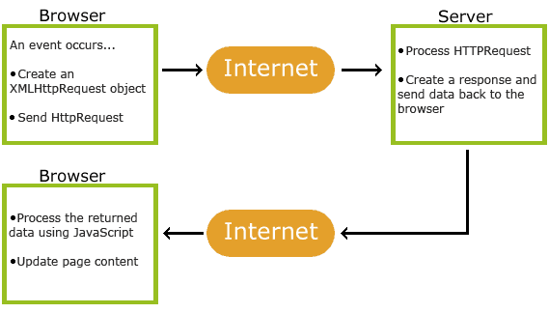

Ajax removes the need for a webpage to refresh every time something changes. This is done by exchanging data with the web server.

The process is as follows:

* 1. An event occurs in a web page (the page is loaded, a button is clicked)
* 2. An XMLHttpRequest object is created by JavaScript
* 3. The XMLHttpRequest object sends a request to a web server
* 4. The server processes the request
* 5. The server sends a response back to the web page
* 6. The response is read by JavaScript
* 7. Proper action (like page update) is performed by JavaScript